**COMPUTER NETWORK SECURITY**

**LAB-7**

**FIREWALL EVASION LAB**

NAME: VISHWAS M

SRN: PES2UG20CS390

SEC: F

DATE:26/10/2022

**Task 0: Get Familiar with The Lab Setup**

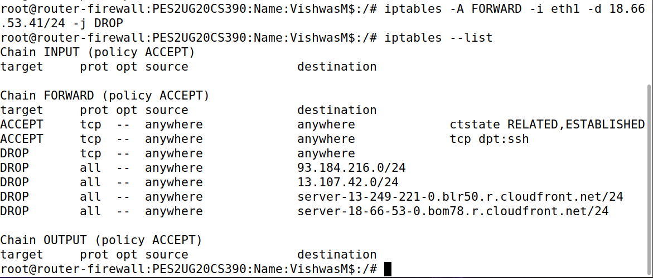

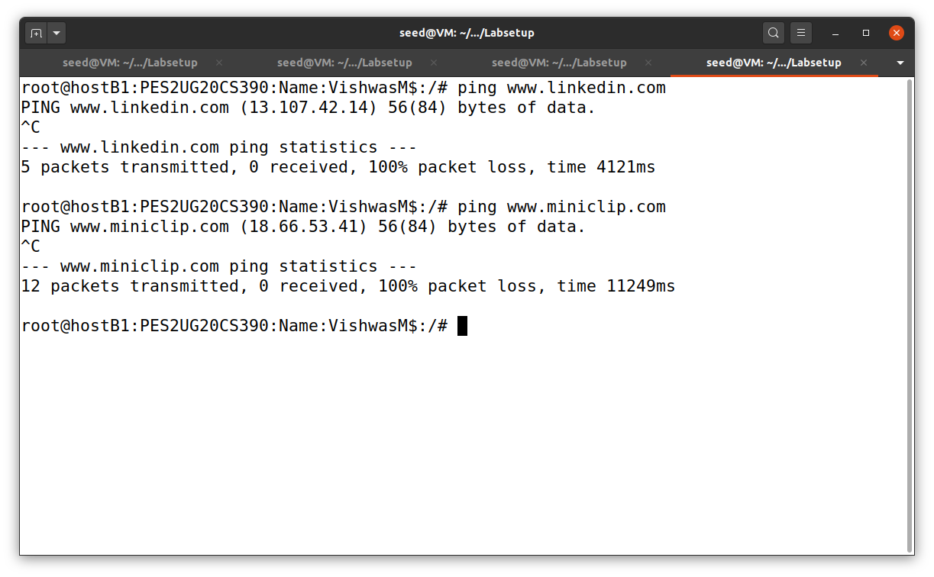

**Task1: Static Port Forwarding**

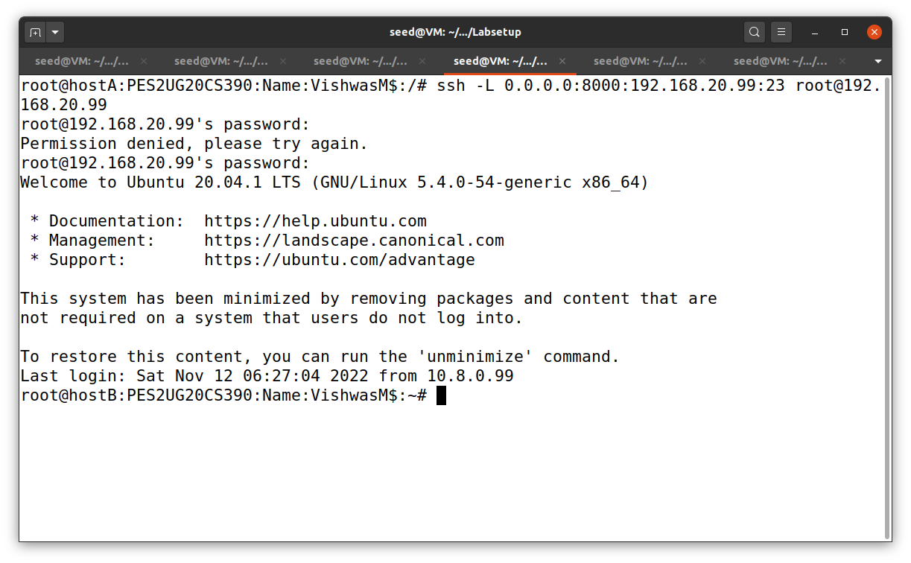

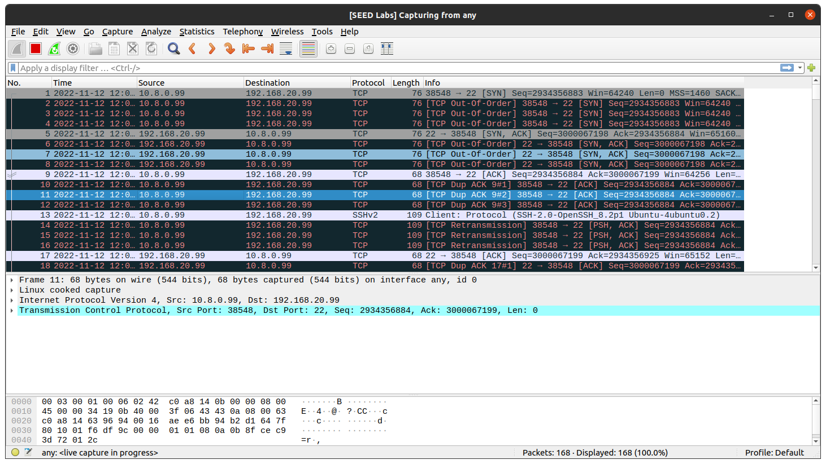

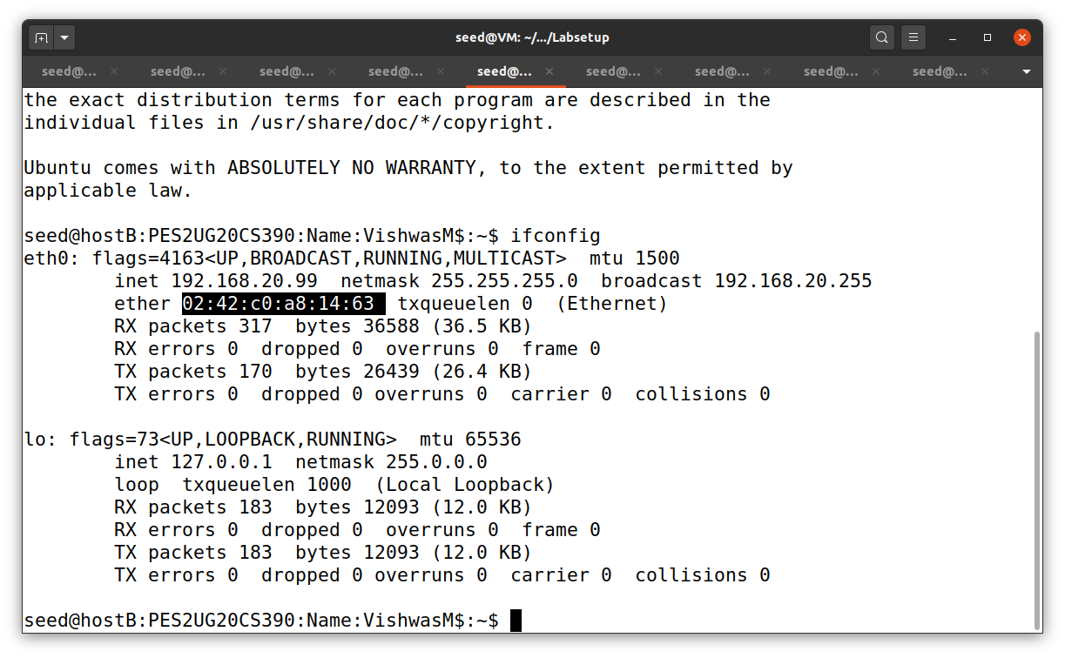

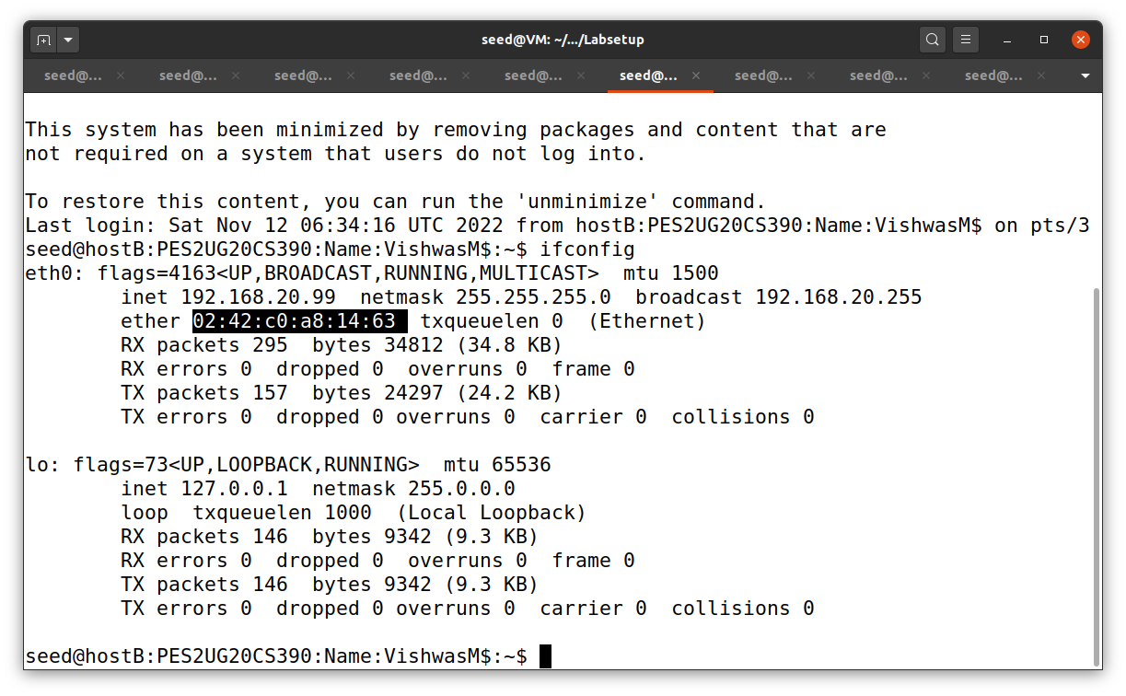

**Task 2: Dynamic Port Forwarding**

**Task 2.1: Setting Up Dynamic Port Forwarding**

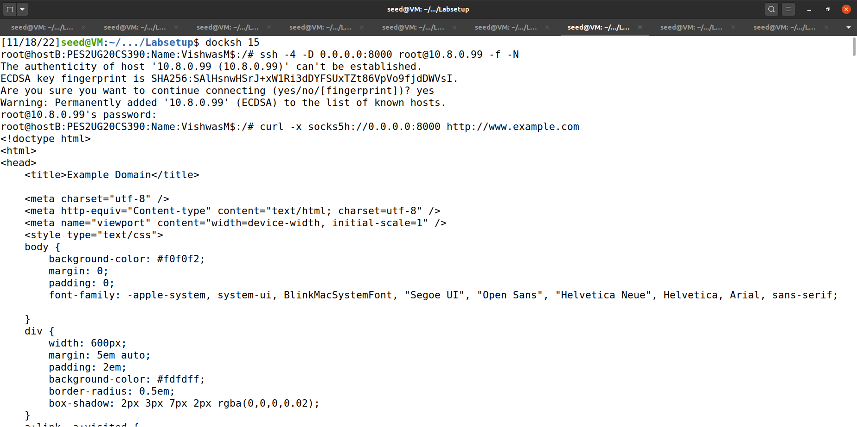

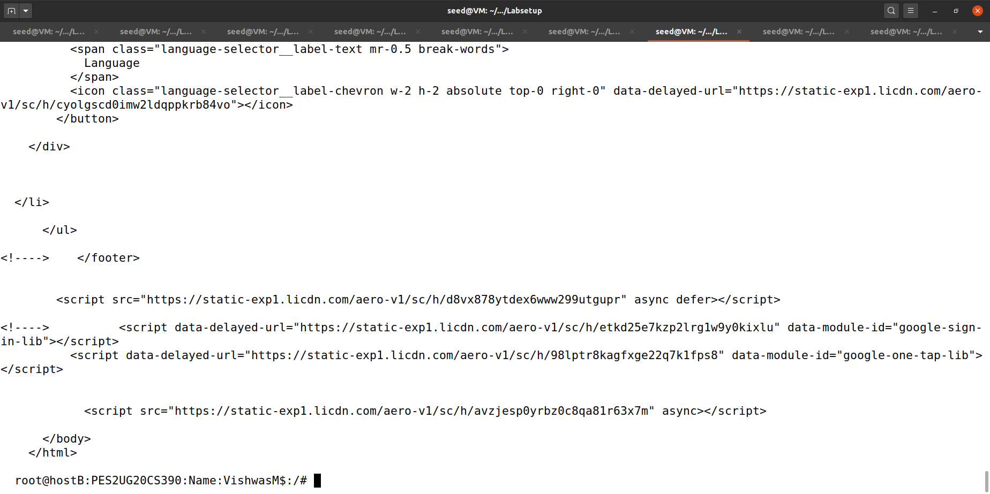

We created a ssh tunnelling between the servers to extract the websites that are blocked by the firewall.

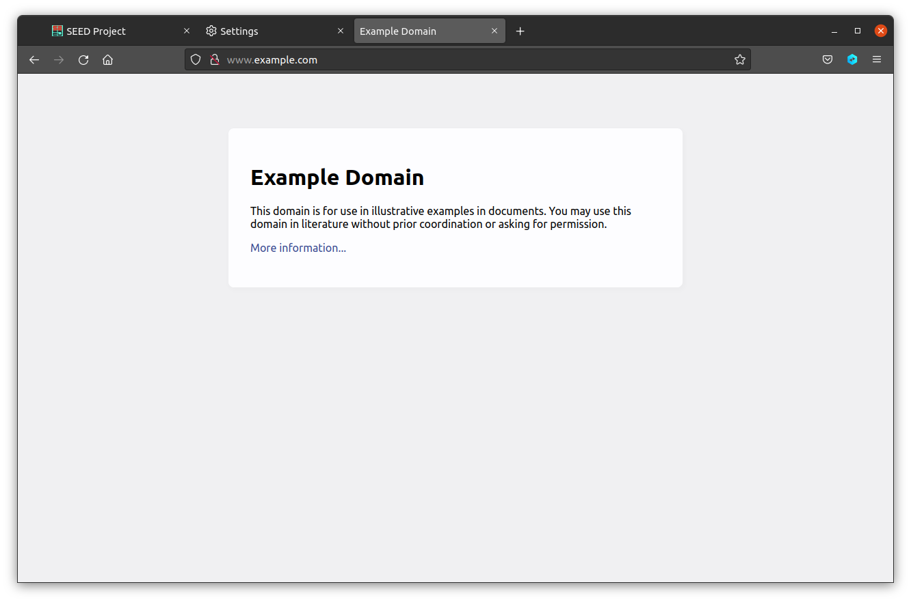

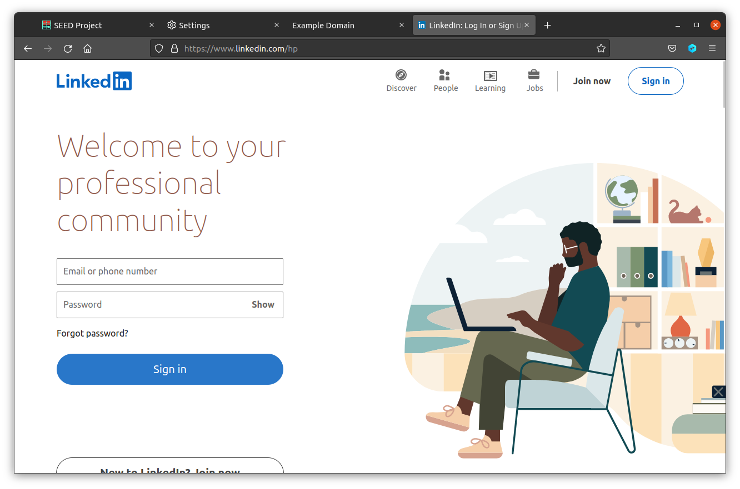

As we can see, the websites are available and are able to reach by the help of ssh tunnelling

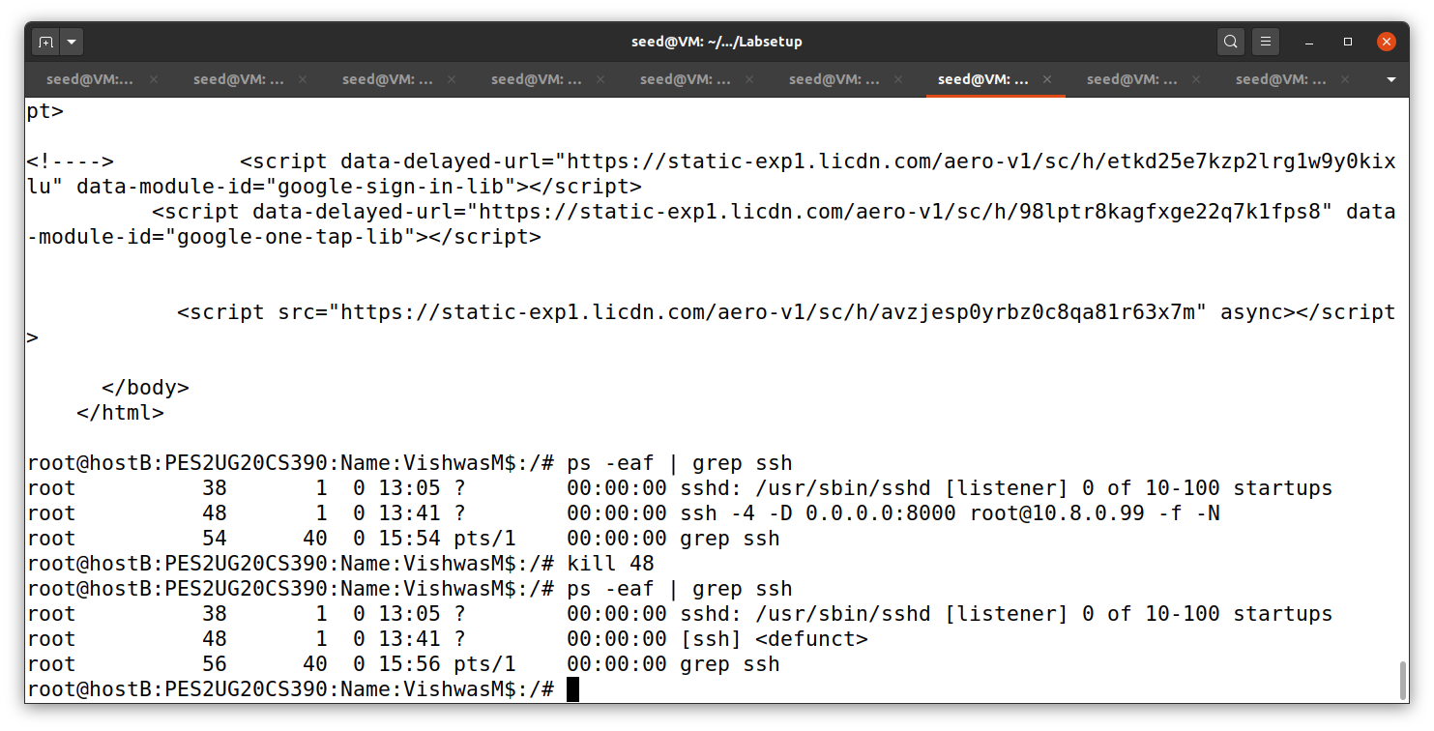

We are killing the ssh tunnel and checking whether we ae able to reach the websites in the next task.

**Task 2.2: Testing the Tunnel Using Browser**

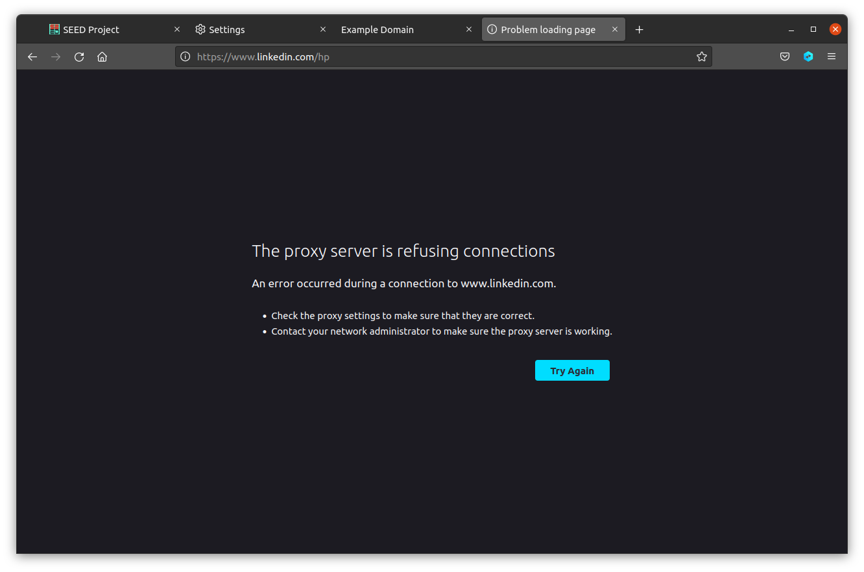

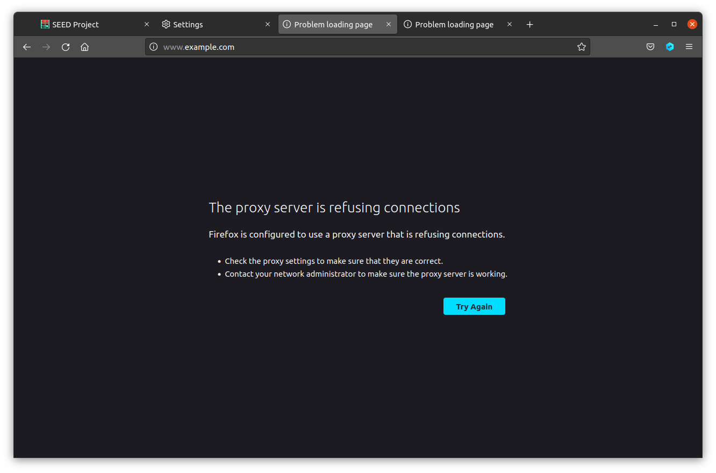

As we can see here we cannot reach the websites as we have removed the ssh tunnelling.

**Task 2.3: Writing a SOCKS Client Using Python**

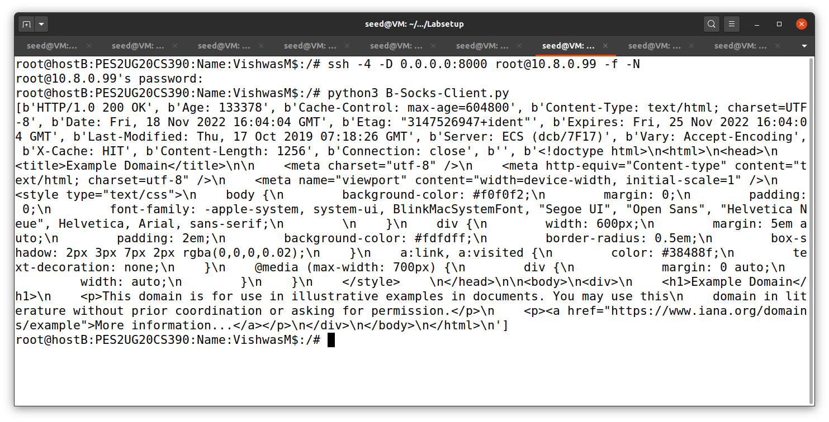

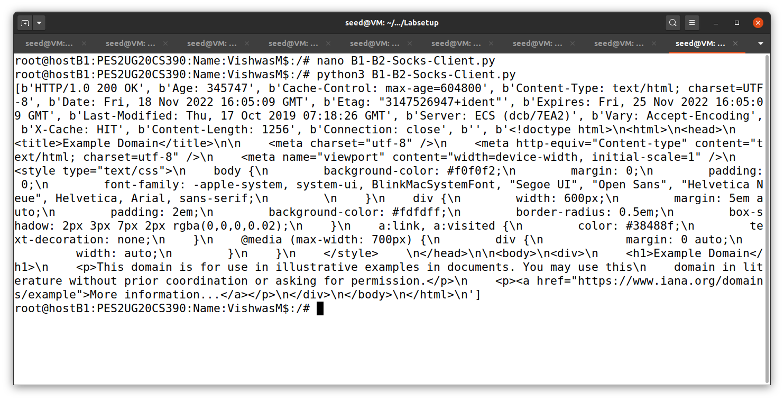

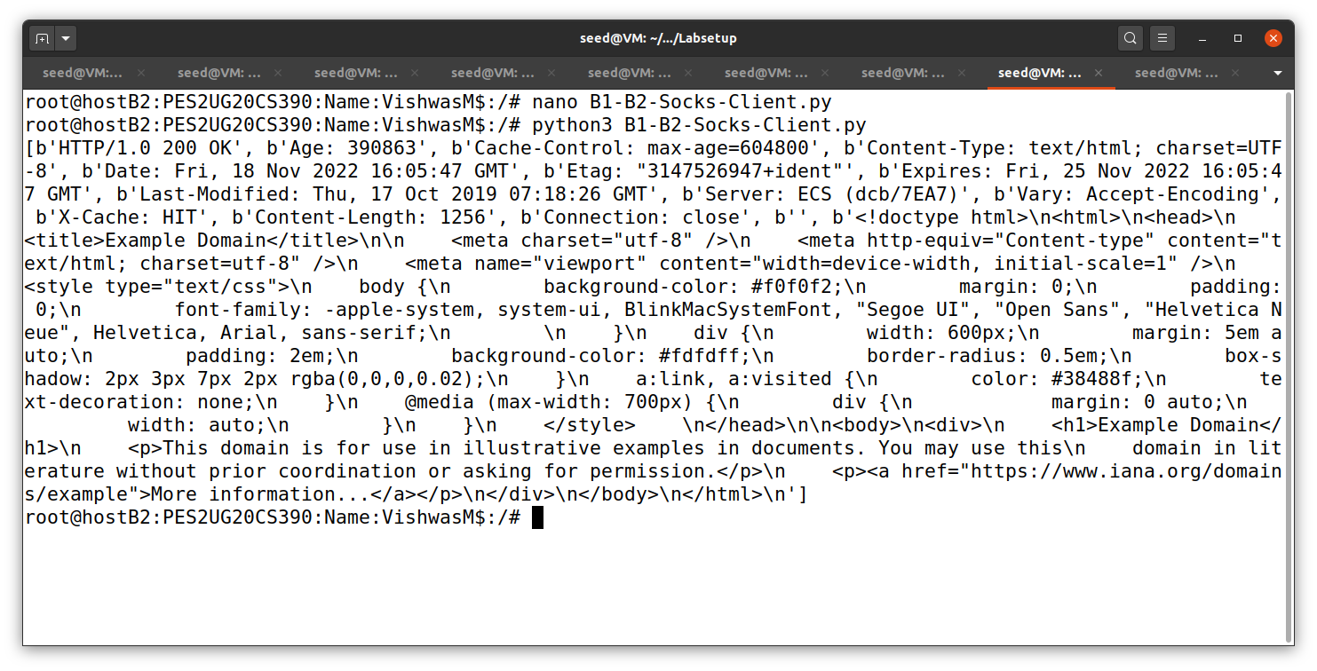

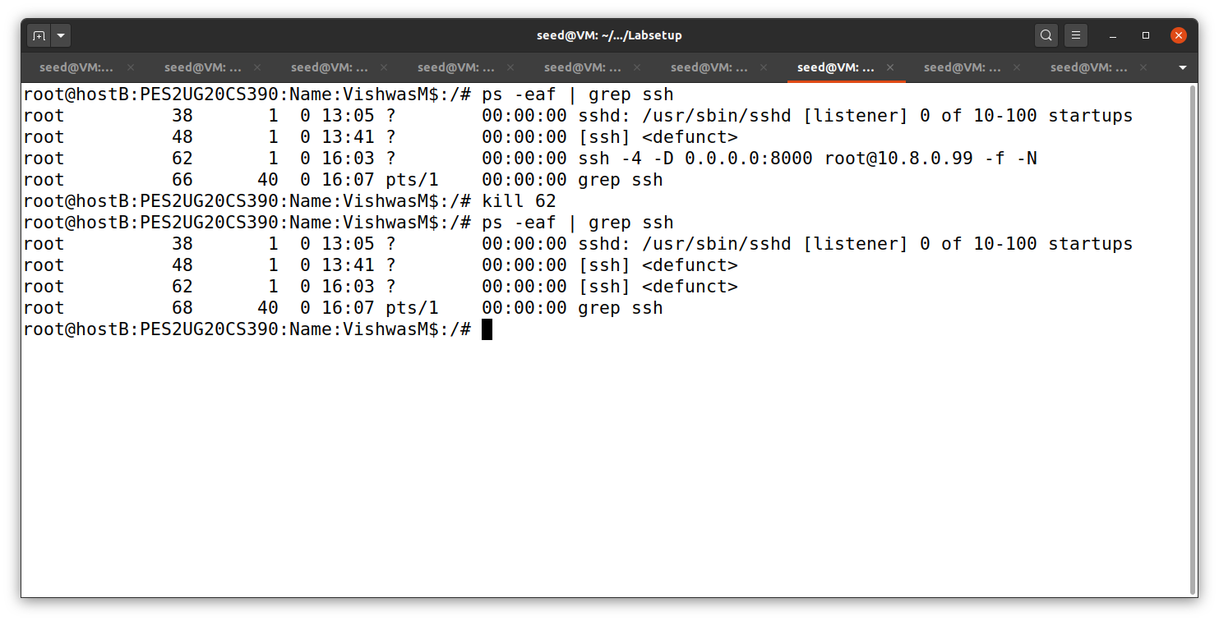

**Task3: Comparing SOCKS5 Proxy and VPN:**

SOCKS5 and VPN do a similar job in computer networking system. They are used to bypass the security and go pass through it reach the servers which are not meant to be visited. SSH tunnelling is little bit faster than VPN. Firewalls usually block some of the websites. These websites can be reached with the help of SSH Tunnelling and VPN.